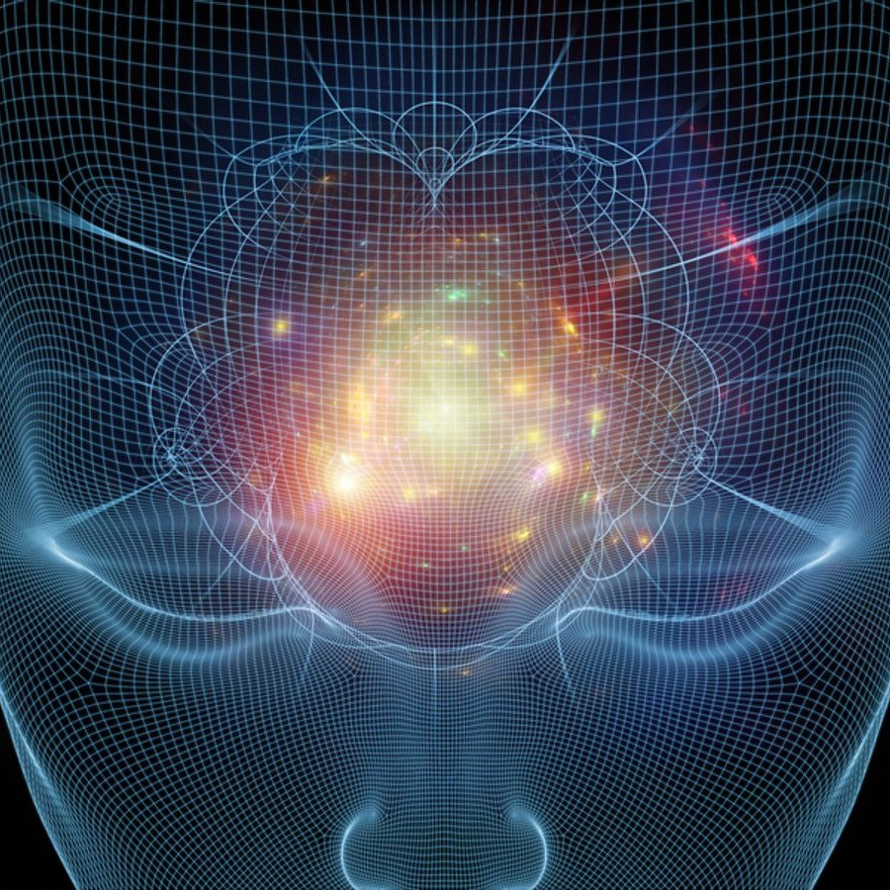MIND YOUR THOUGHTS

## Scan to review worksheet Expemo code:

QrrkoD

**131Z-14RD-KS66**

# Warm-up

**1**

**Do you think it will be possible for a computer to read your mind? Why/why not?**

I think read the minds is impossible, and more impossible is for the computers do this action. Only there is a form to read the mind and is with microchips implanted in the head. And, thinking more, the computers can have, in a far future, the possibility of program these microchips and, with a new technology idea, get the head information of the people. I think is possible because the technology is in a continued advance.

# Key words

**2**

## Match the words to their deﬁnitions.

### capable of (something) a. going into somewhere without being wanted

1. intrusion b. having the ability to be able to do something

### ensure c. progress in an area of science or technology

1. self-determination d. the ability to make decisions for yourself

### sophisticated e. the use of something in a harmful way

1. paralysed f. to make certain something is done or happens

### advances g. unable to move all or part of your body because of illness or injury

1. abuse h. very advanced

1-b 2-a 3-f 4-d 5-h 6-g 7-c 8-e

UPPER-INTERMEDIATE (B2-C1)

HEAAADERLOGORIGHT



MIND YOUR THOUGHTS

# Reading

**3**

## You are going to read an article about how machines will be able to read our thoughts in the future. Before you read, decide whether the statements below are ‘T’ (true) or ‘F’ (false). Then read the text on the next page to conﬁrm or correct your answers.

### Scientists think that we need laws to protect us from the intrusion of machines into our minds.T->T

1. Social media sites are concerned about what will happen if machines are able to read our thoughts.F->F

### People will be aware that a computer is reading their thoughts.T->F

1. Experts are anxious that new brain technology will be misused.T->T

### Companies are not allowed to use technology that produces an image of the brain to help them understand their customers.F->T

1. According to the article, most people think that computers are only able to read people’s minds in science ﬁction stories.T->T

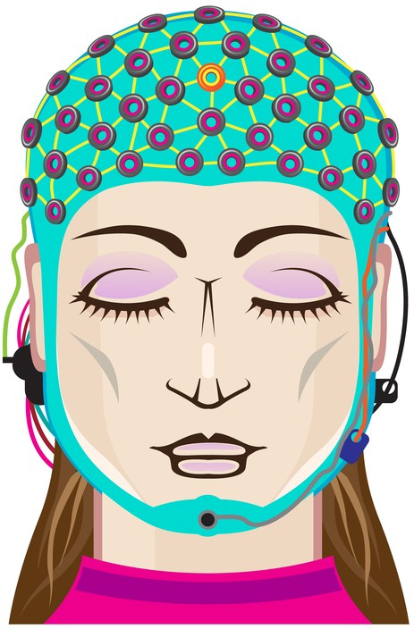



**New computers could delete thoughts without your knowledge, experts warn**

## New human rights laws are required to protect sensitive information in a person’s mind from ‘unauthorised collection, storage, use or even deletion’

**1.** Technological advances in machines that can read our thoughts mean that the privacy of our brain is under threat.

**2.** Now, two biomedical scientists are calling for the creation of new human rights laws to ensure people are protected. The new laws include the right to mental privacy and the right of humans to control their own mental processes.

**3.** Scientists have already developed devices capable of telling whether people are politically right-wing or left-wing. In one experiment, researchers were able to read people’s minds to tell with 70 per cent accuracy whether they planned to add or subtract two numbers.

**4.** Facebook also recently revealed it had been secretly working on technology to read people’s minds so they could type by just thinking.

**5.** Medical researchers have also managed to connect part of a paralysed man’s brain to a computer to allow him to stimulate muscles in his arm so he could move it and feed himself.

**6.** The scientists also stressed the "unprecedented opportunities" that would result from the distribution of cheaper and easier to use applications that would make neurotechnology* part of our everyday lives.

**7.** However, the academics made it clear that these devices were open to abuse on a frightening level.

**8.** And they warned that the techniques were so sophisticated that people’s minds could be read or interfered with without their knowledge.

**9.** They said that illegal intrusion into a person’s mind could happen not because they were persuaded to allow it, but because they weren’t aware it was happening.

**10.** Professor Roberto Andorno, an academic at Zurich University’s law school and a co-author of the paper, said that brain imaging technology had already reached a point where there had been discussion about whether it could be used in a criminal court, for example when assessing the risk of a criminal re- oﬀending.

**11.** He also said that consumer companies were using brain imaging for ‘neuromarketing’ to understand consumer behaviour and to achieve desired responses from customers.

**12.** He added that there were also tools such as ‘brain decoders’ which can turn brain imaging data into images, text or sound.

**13.** His colleague Marcello Ienca, of the Institute for Biomedical Ethics at Basel University, said: "The mind is considered to be the last refuge of personal freedom and self-determination, but advances in neural engineering, brain imaging and neurotechnology put the freedom of the mind at risk."

**14.** He admitted such advances might sound like something out of the world of science ﬁction.

**15.** But he added: "Neurotechnology featured in famous stories has in some cases already become a reality, while others are inching ever closer, or exist as military and commercial prototypes."

**16.** "We need to be prepared to deal with the impact these technologies will have on our personal freedom."

*Adapted from the Independent by Ian Johnston, 26th of April 2017*

* neurotechnology = technology used to interact with the brain and nervous system

# Checking understanding

**4**

## What do you remember? Answer the questions according to the article.

### What do scientists think should be included in the new laws that will help to protect our brains?

### Scientist think should be included in the new laws the right to mental privacy and the right humans to control their own mental processes.

1. What can scientists tell about a person’s political position using a special device?

Scientists can tell about a person’s political position using a special device that are capable of telling whether people are politically right-wing or left-wing.

### What was a paralysed man able to do when his brain was connected to a computer?

### A paralysed man was able to stimulate muscles in his arm so he could move it and feed himself.

1. How could brain imaging be useful in criminal cases?

Brain imaging can be useful in criminal cases for example when assessing the risk of a criminal reoffending.

1. What can brain ’decoders’ do?

Brain decoders can turn brain imaging data into images, text or sound.

# Find the words

**5**

## Find a word or phrase in the text which means ...

1. in danger **(phrase, P.1)**: the privacy of our brain is under threat
2. possibilities that haven’t existed before **(phrase, P.6)**: the scientists also stressed the unprecedented opportunities
3. people who teach and do research at colleges or universities **(noun - plural, P.7)**: academics
4. changed without permission **(phrasal verb - past participle form, P.8)**: could be read or interfered
5. wanted **(adj., P.11)**: desired
6. the ﬁnal safe place **(collocation, P.13)**: mind
7. becoming much nearer **(phrase, P.15)**: while others are inching ever closer

# Prefixes

**6**

## Match the preﬁxes to their deﬁnitions.

### neuro- a. again

1. bio- b. original

### de- c. relating to living things

1. proto- d. relating to nerves

### co- e. remove

1. re- f. together

1-d 2-c 3-e 4-b 5-f 6-a

## Now, ﬁnd examples of words in the text with each of the above preﬁxes which show these meanings.

### .Neurotechnology, biomedical, decoders, prototypes, co-auhor and researchers . . . . . . . . . . . . . .. . . . . . . . . . . . . . . . . . . . . . . . . . . . . . . . . . . . . . . . . . . . . . . . . . . . . . . . . . . . . . . . . . . . . . . . . . . . . . . . . . . .

. . . . . . . . . . . . . . . . . . . . . . . . . . . . . . . . . . . . . . . . . . . . . . . . . . . . . . . . . . . . . . . . . . . . . . . . . . . . . . . . . . . . . . . . . . . . . . . . . . . .

### . . . . . . . . . . . . . . . . . . . . . . . . . . . . . . . . . . . . . . . . . . . . . . . . . . . . . . . . . . . . . . . . . . . . . . . . . . . . . . . . . . . . . . . . . . . . . . . . . . . .



UPPER-INTERMEDIATE (B2-C1) MIND YOUR THOUGHTS

# Talking point

HEAAADERLOGORIGHT

**7**

## Discuss any of the questions below.

### Do you think that we will need laws to protect ourselves from machines collecting or deleting information in our brains? Why/why not?

### Yes, because it would not be acceptable for anyone could collect the information from the brains with impunity, without there being laws that control this. These laws are necessary to prevent, above all, the misuse of this information.

1. Do you believe what is written in the article or do you think that this type of thing is only possible in science ﬁction books? Why/why not?

I do not think it is only science fiction, since there are currently studies and the possibility that in the future it can be done.

### Do you think that neurotechnology will do more harm than good? Why/why not?

### After all, anything that enters people's minds is harmful. It is not natural to go in and know what others are thinking. In that sense, I think that neurotechnology is taking steps that we will regret in the future.